ChargeScape: EV Analytics Dashboard

# 🔋 Project Overview

ChargeScape is a data-driven project exploring the global landscape of electric vehicles (EVs) using the IEA Global EV Dataset (2024). This dashboard provides visual insights into EV adoption patterns, powertrain composition, regional trends, and year-wise growth to support stakeholders in understanding the dynamics of electric mobility.

# 🛠️ Tools & Technologies Used

- Python (Google Colab): Data Cleaning, EDA  
- Tableau: Interactive Dashboard Design  
- GitHub: Project Version Control & Portfolio Showcase

# 📊 Step-by-Step Process

## Step 1: Data Cleaning & EDA in Google Colab

The raw dataset 'IEA Global EV Data 2024.csv' was loaded into Google Colab. Using Python libraries like Pandas and NumPy, the dataset was cleaned and explored.

Key steps included:

* - Importing the dataset
* - Checking for null values
* - Grouping and summarizing data for Tableau
* - Exporting the cleaned file as 'clean_ev_data.csv'

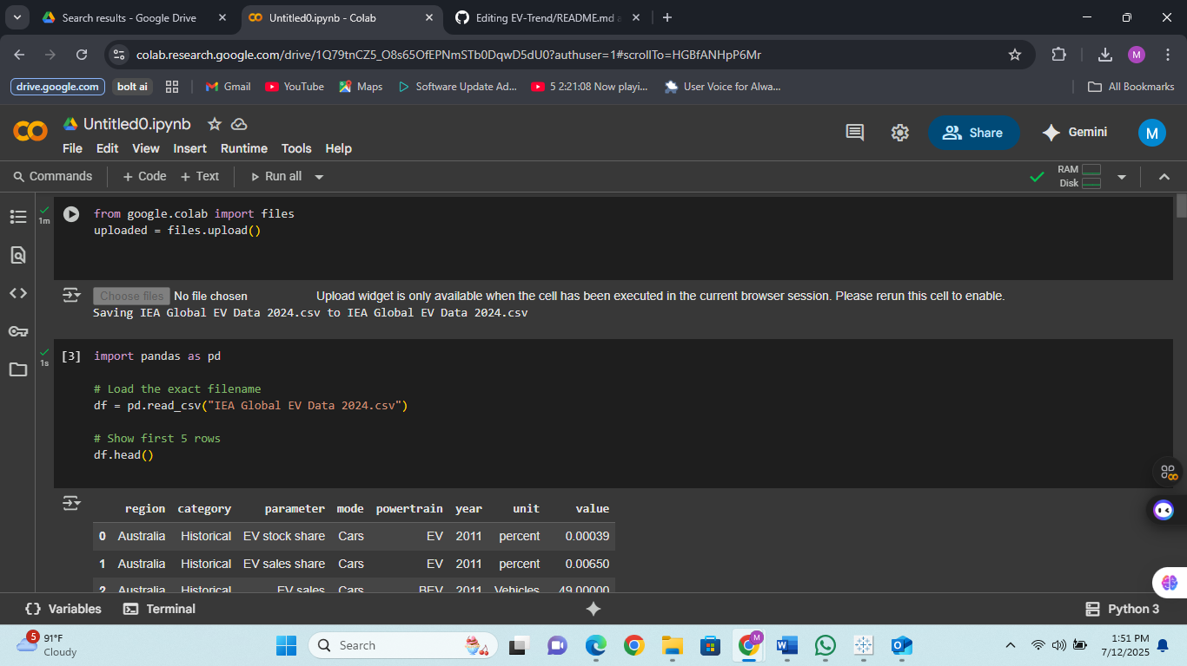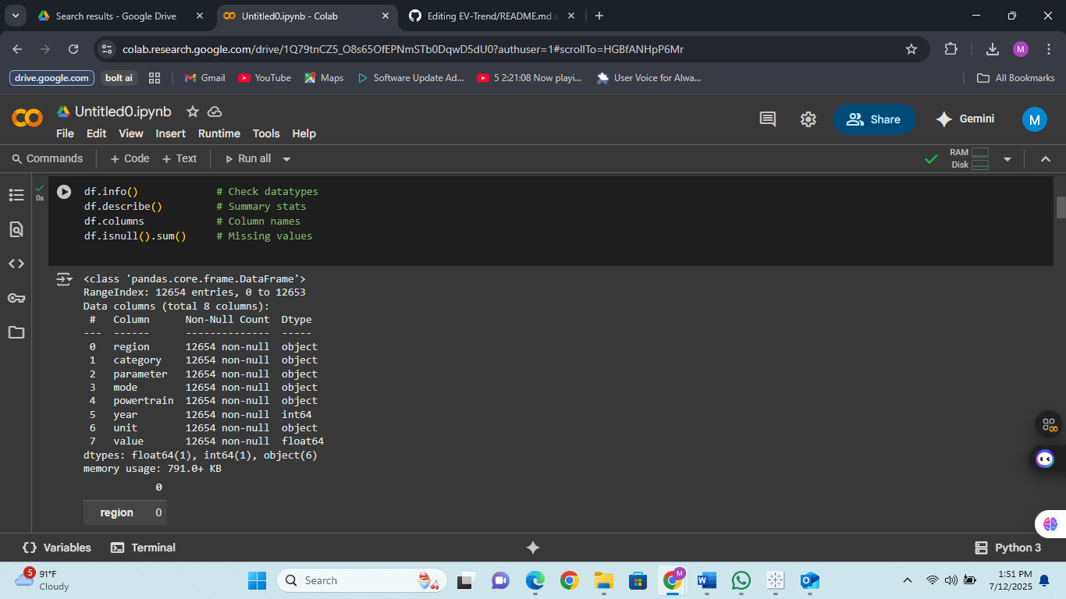

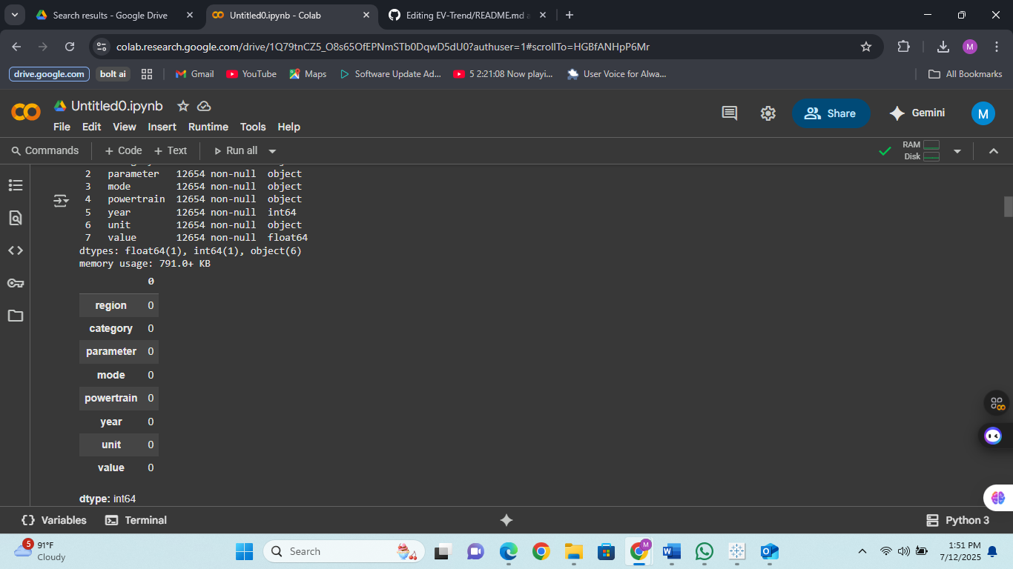

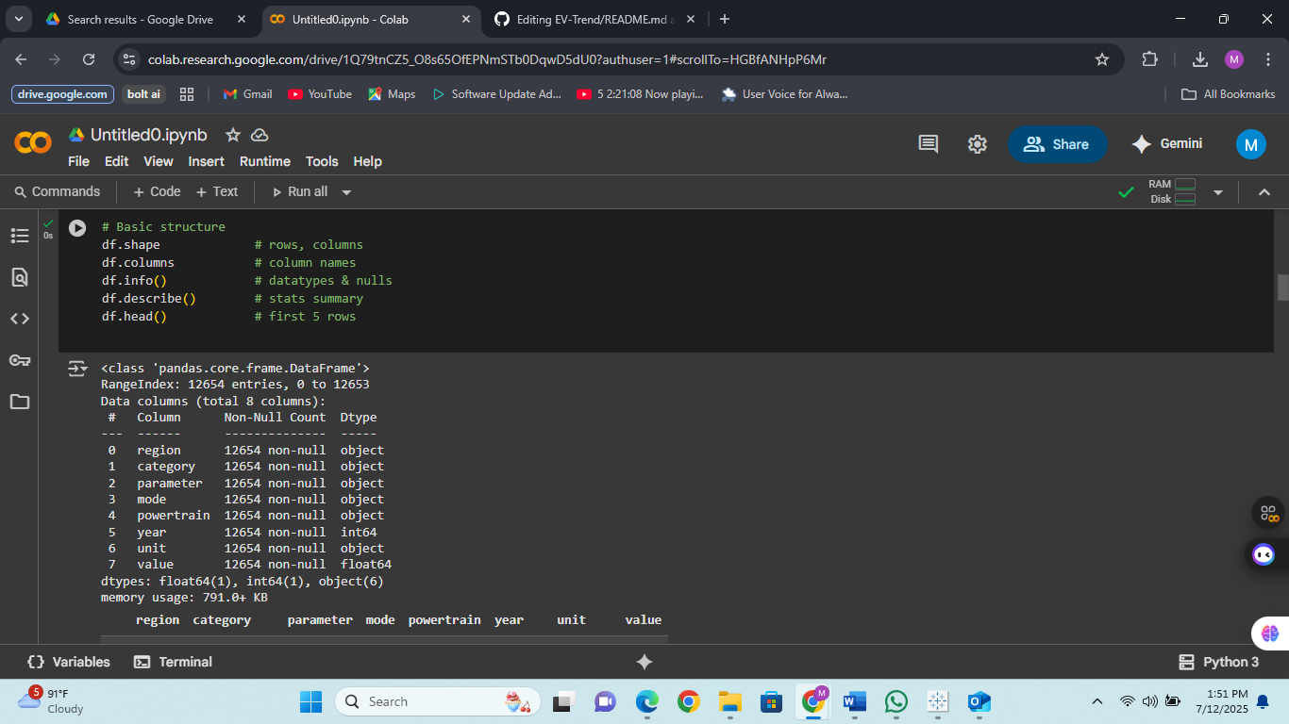

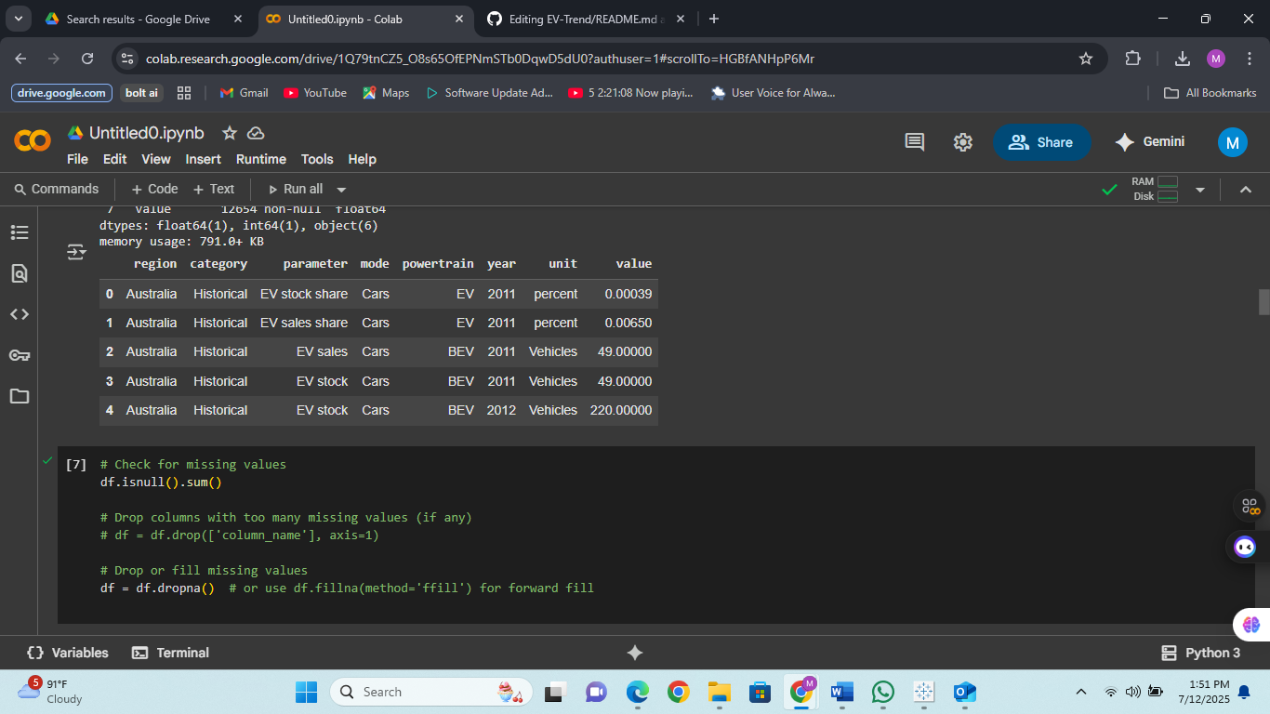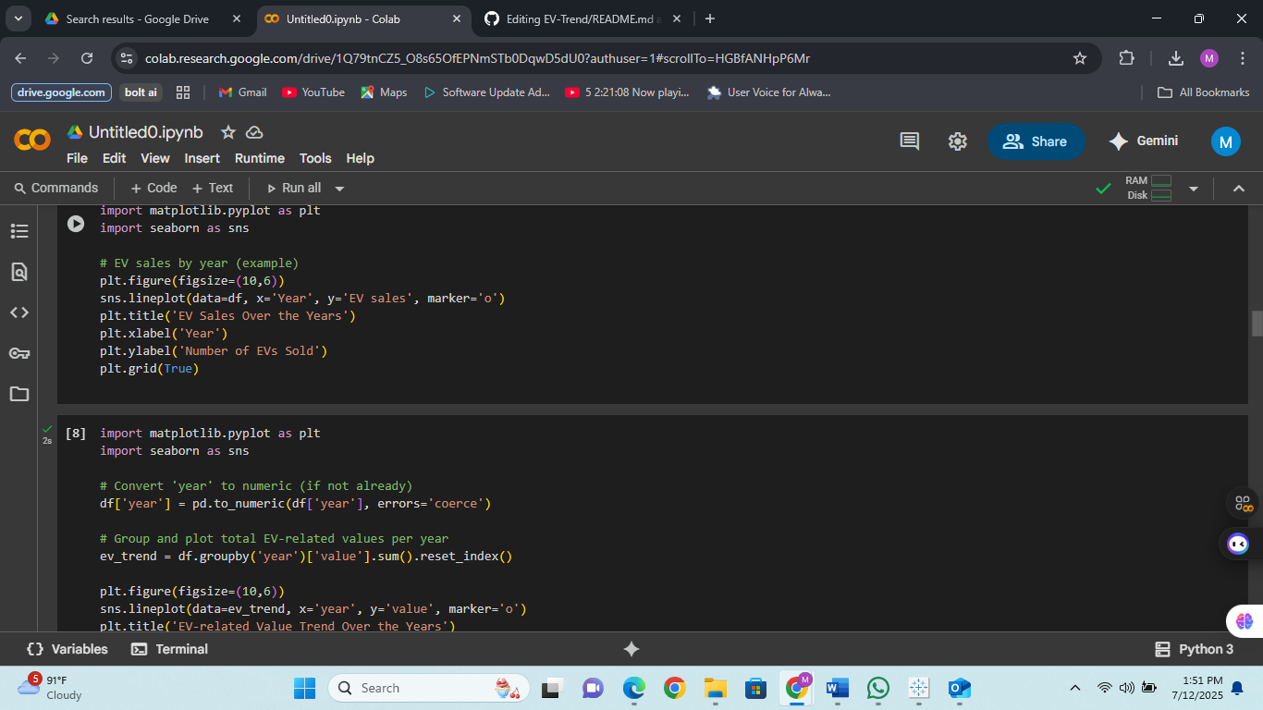

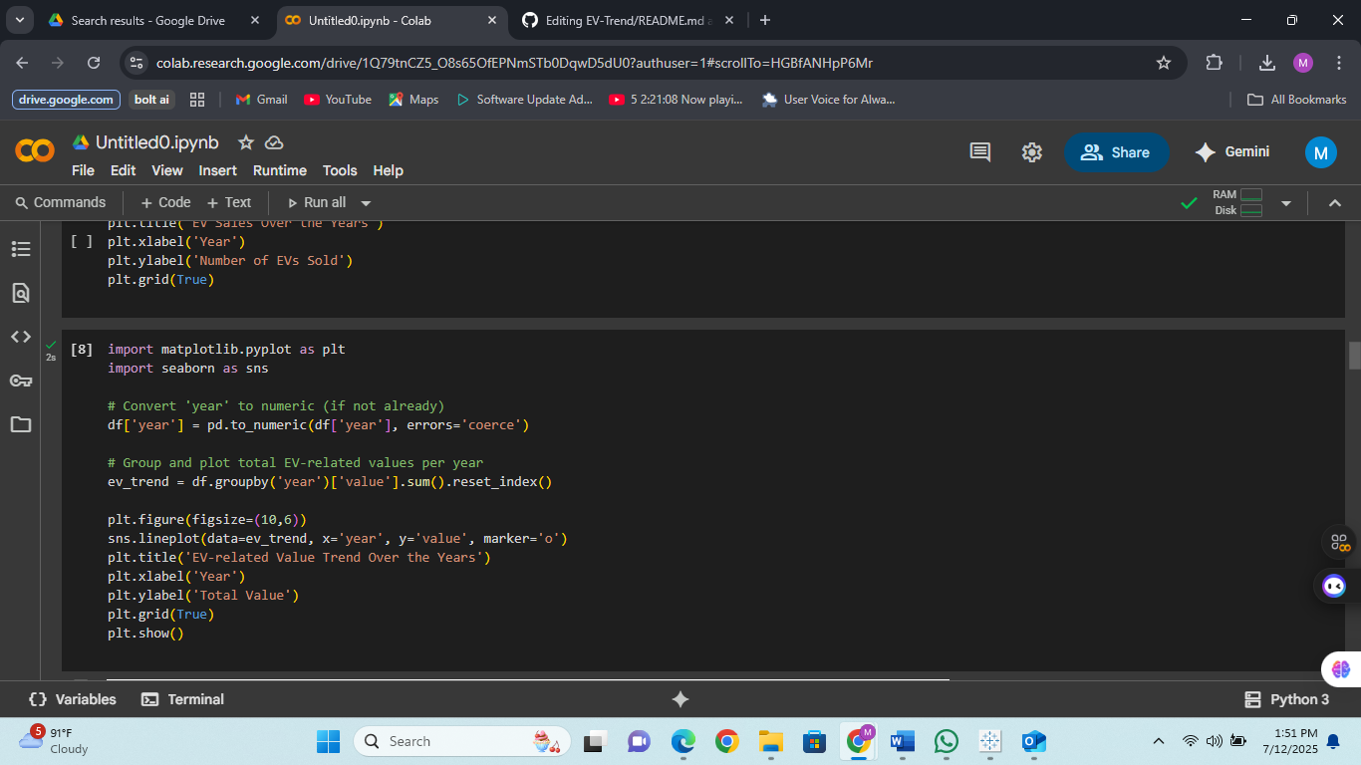

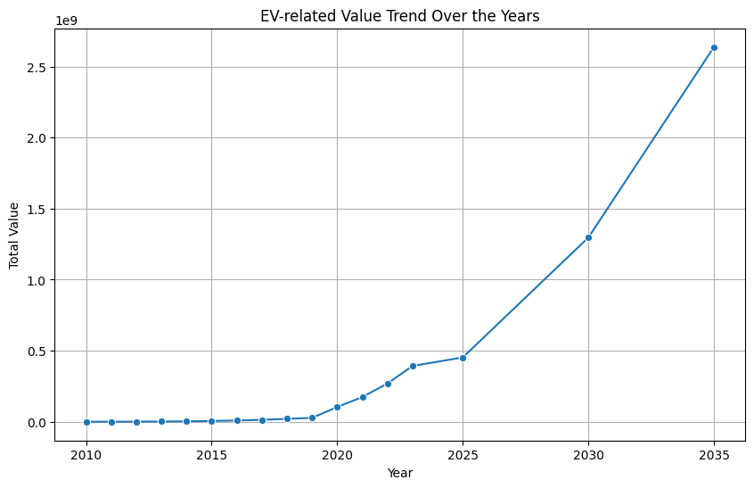

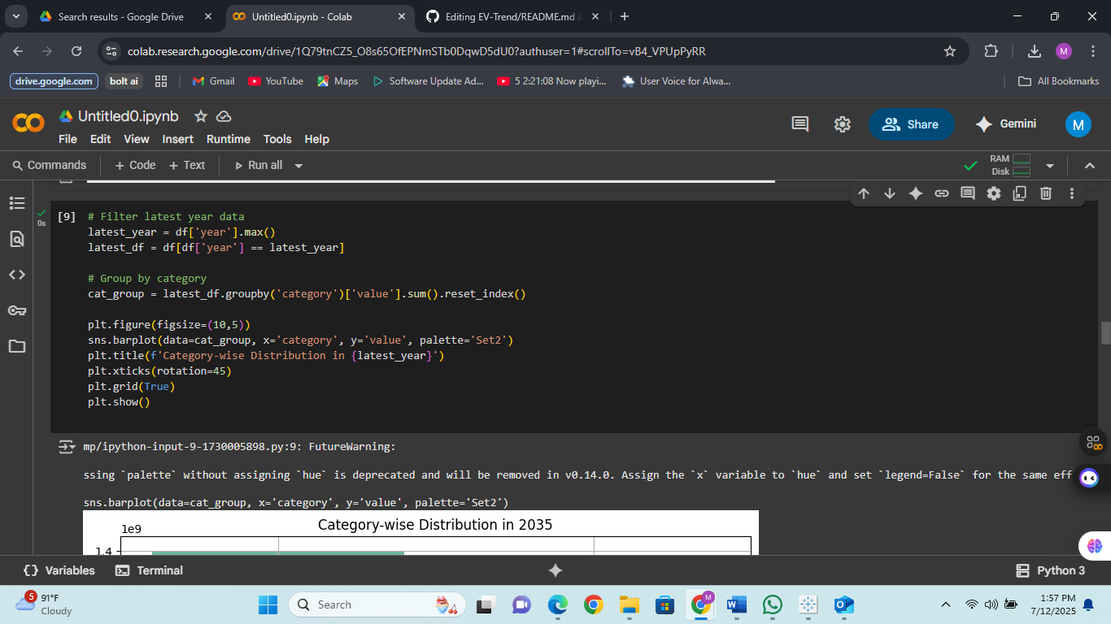

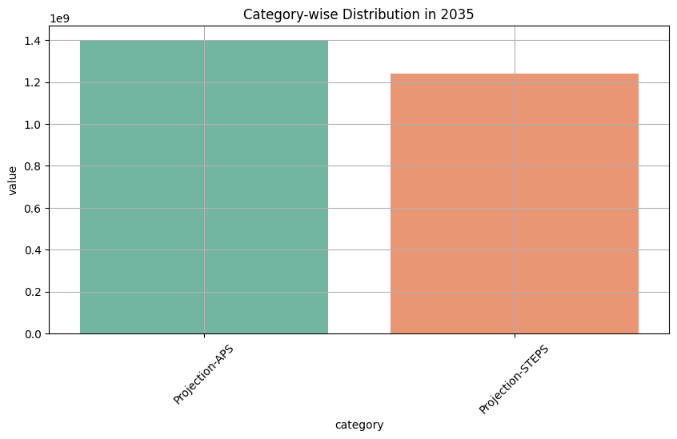

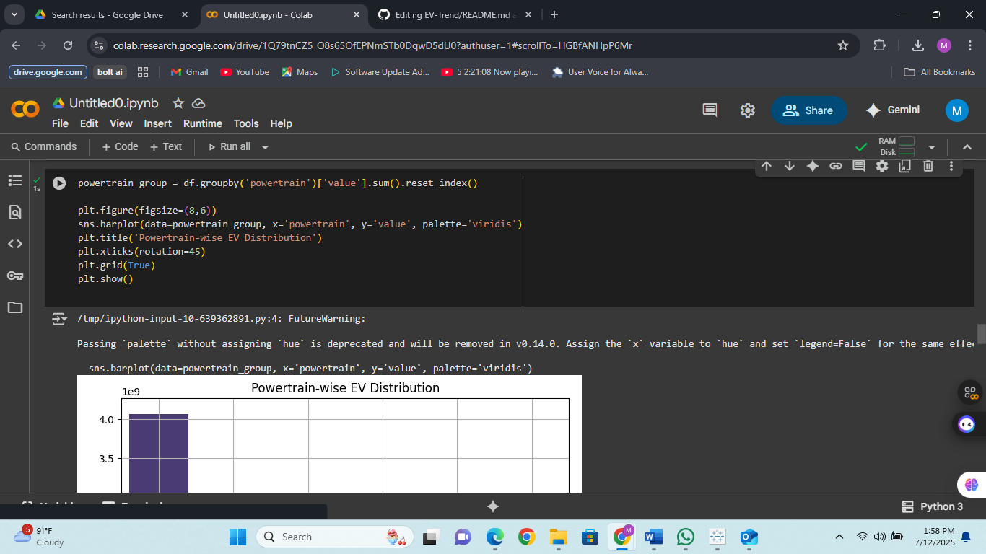

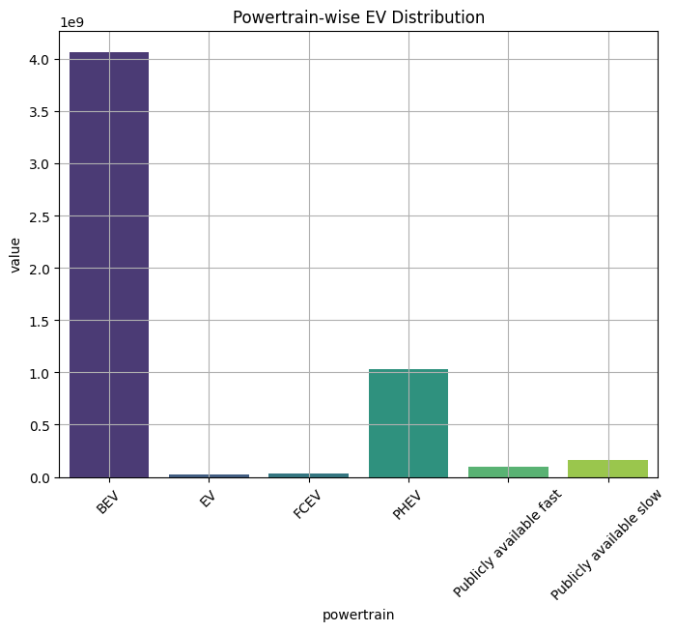

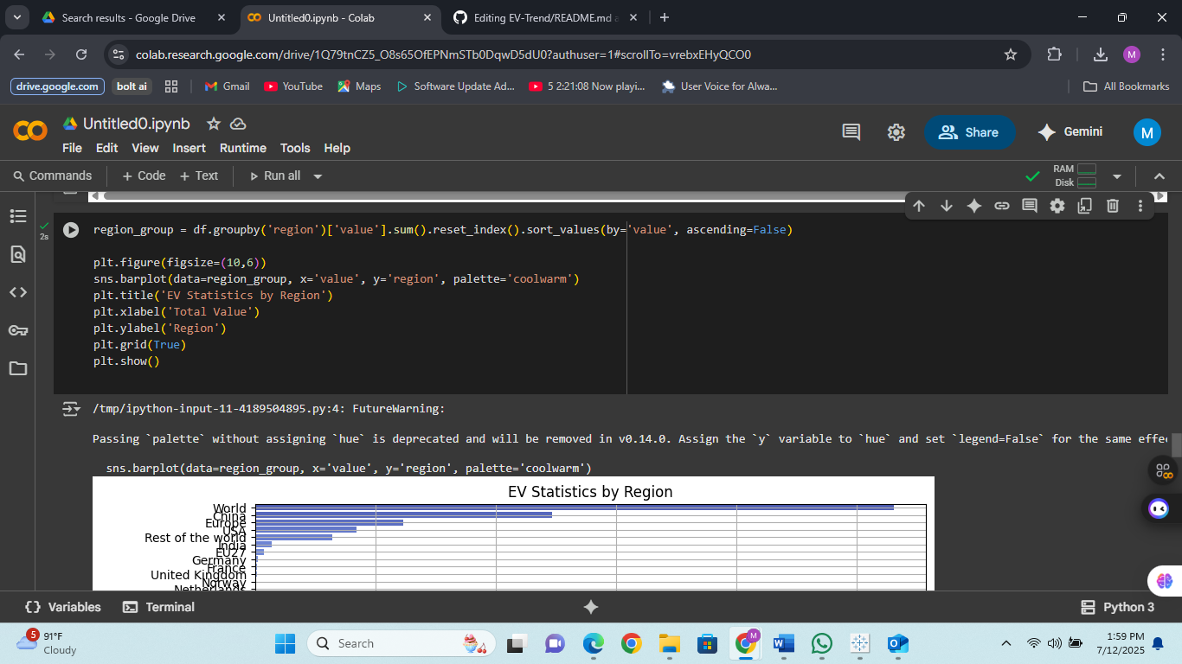

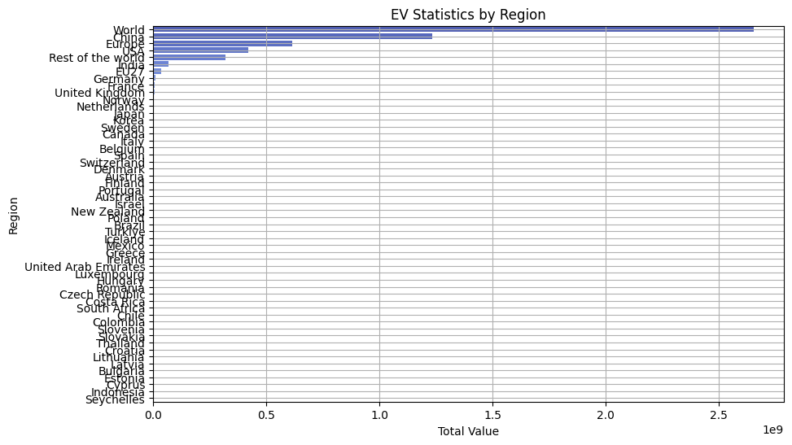

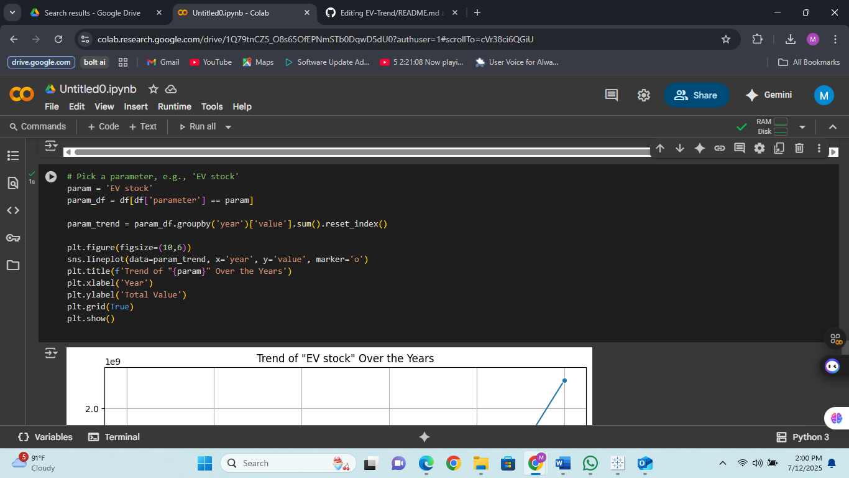

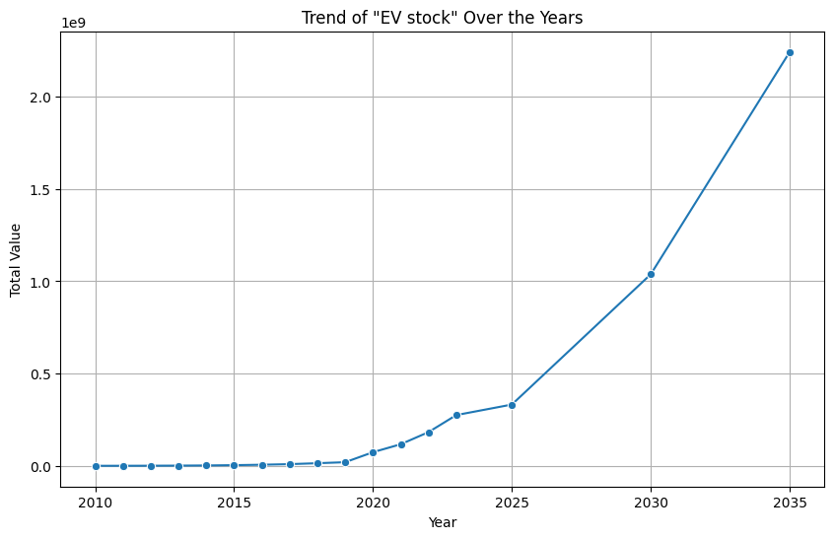

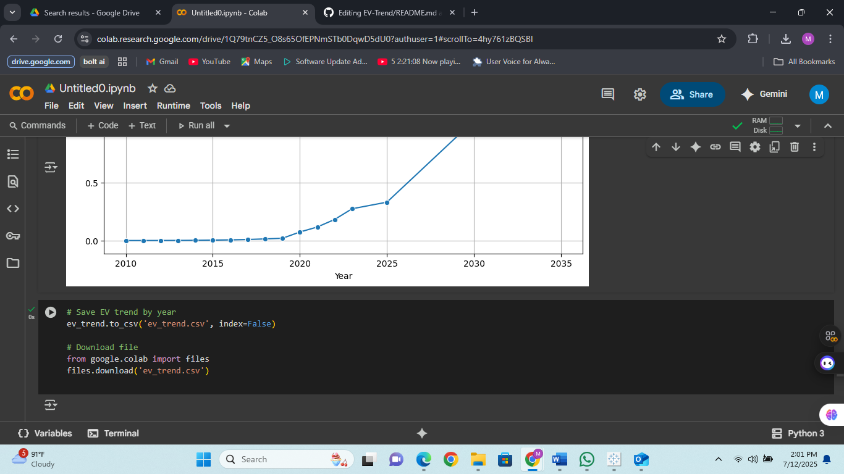

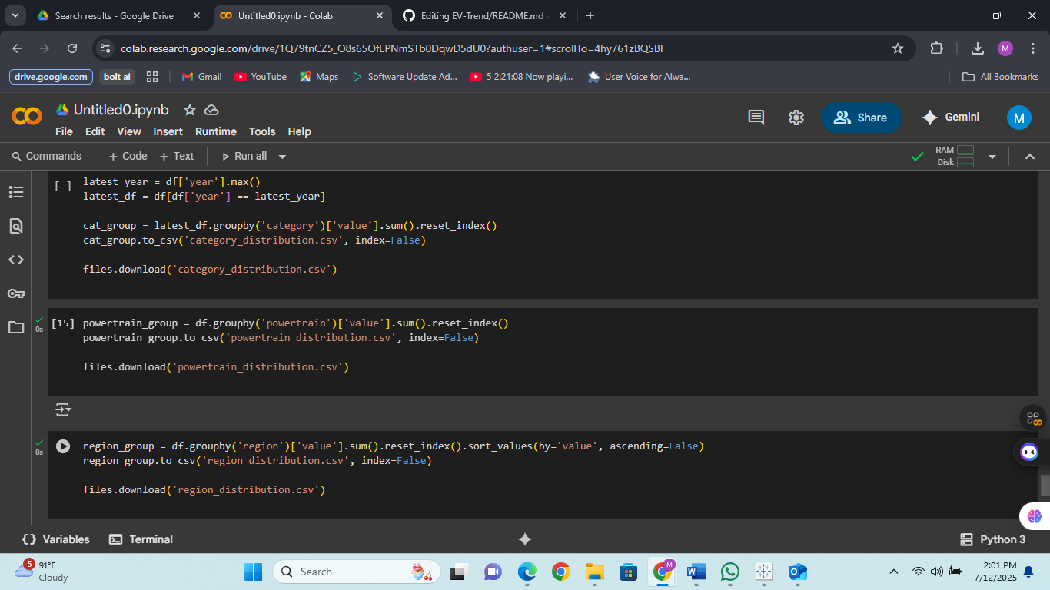

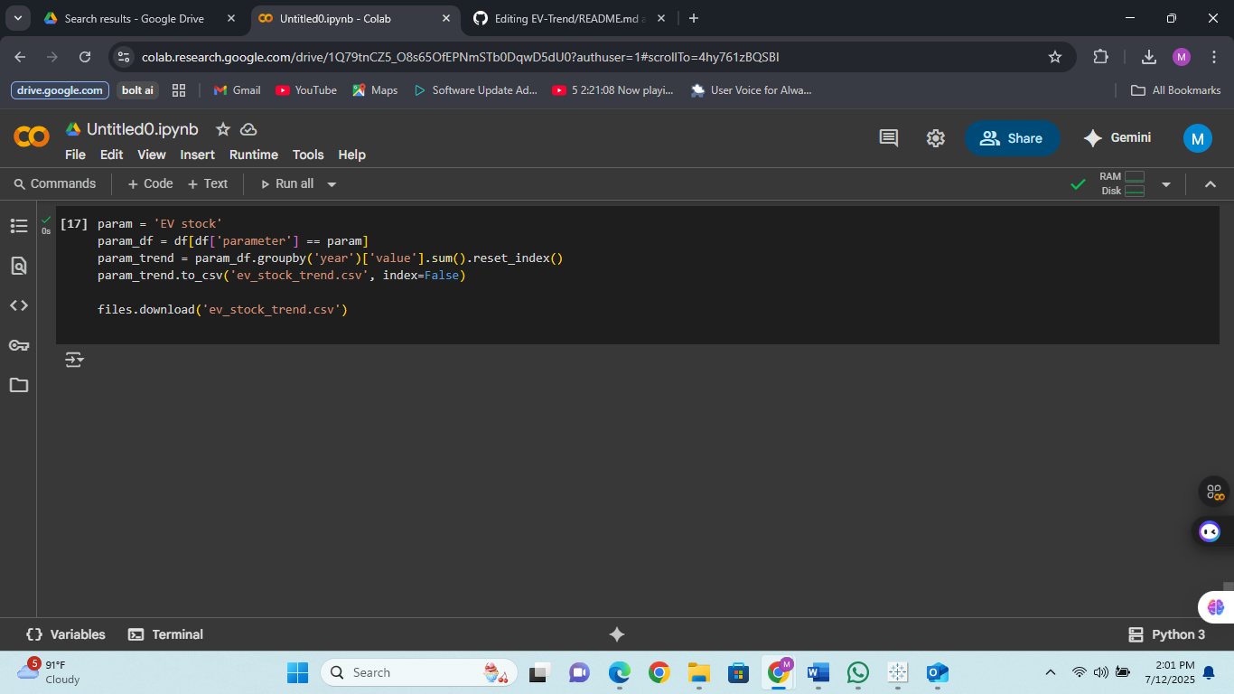

## Step 2: Dashboard Creation in Tableau

The cleaned CSV was imported into Tableau. Multiple visualizations were created such as donut charts, filled maps, lollipop charts, and line graphs to showcase the following insights:

* - Powertrain-wise composition
* - Region-wise EV adoption
* - Year-over-year EV growth

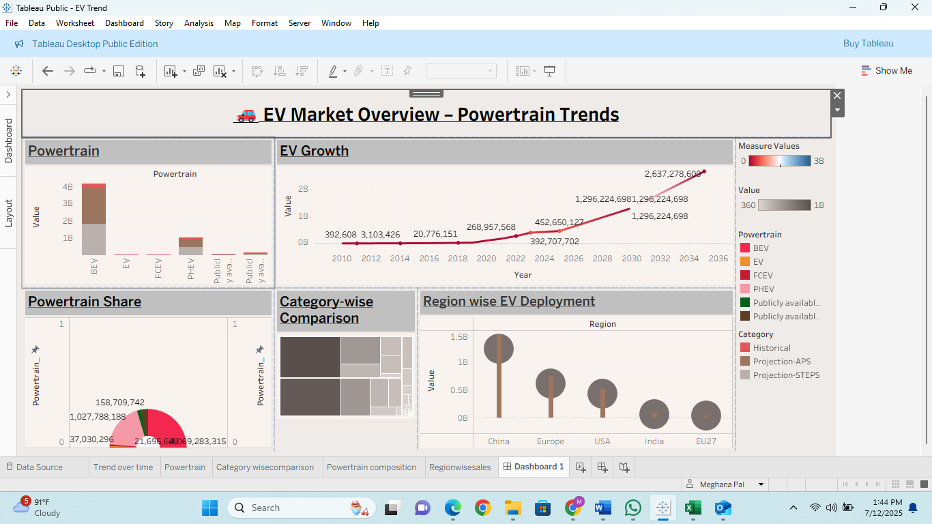

## Step 3: Upload to GitHub

The following files were uploaded to GitHub to showcase the project:  
- clean_ev_data.csv  
- Tableau dashboard file (.twbx)  
- Project images (dashboard screenshots)  
- README.md with project description, tools, and insights

# 📁 Project Structure

ev-data-analytics-dashboard/  
├── clean_ev_data.csv  
├── ChargeScape_Dashboard.twbx  
├── charts/  
│ ├── donut_chart.png  
│ ├── filled_map.png  
├── README.md

# 👩‍💻 Author

Meghana Pal  
Aspiring Data Analyst | B.Tech CSE | Passionate about Data & Design  
LinkedIn: https://www.linkedin.com/in/meghana-pal-614627258/  
GitHub: https://github.com/meghanapal